Tab 1

**IT TICKET ANALYSIS**

**Objective Questions :-**

1. **What is the total no. of attributes present in the data?**

* Ticket worksheet has 10 attributes,

IT Agents worksheet has 6 attributes,

Agent ID, Full Name, Email, Year of Birth, Month of Birth, Day of Birth. ID, Ticket Fecha, Employee ID, Request Category, Issue Type , Severity, Priority , Resolution Time (Days), Satisfaction Rate.

**2. Which columns have inconsistent or missing values, and what is the count of such values?**

There is no inconsistent or missing data in the dataset which was provided to us

**3.** **What is the average daily ticket volume over time?**

59.13 is Average Daily ticket volume over time.

Average Daily Ticket Volume=Total Count of Tickets/Number of Days in the Date Range /([Count of ID Ticket] / [Days in Year])

**4. What is the distribution of ticket categories (e.g., Login Access, System, Software)?**

| Request Category | COUNT of Ticket ID |
| --- | --- |
| Hardware | 9733 |
| Login Access | 29193 |
| Software | 19570 |
| System | 39002 |
| Grand Total | 97498 |

**5. How many tickets has each agent handled?**

| Agent ID | COUNT of Ticket ID |
| --- | --- |
| 1 | 1969 |
| 2 | 1968 |
| 3 | 2021 |
| 4 | 1988 |
| 5 | 2000 |
| 6 | 1949 |
| 7 | 1935 |
| 8 | 1960 |
| 9 | 1949 |
| 10 | 1974 |
| 11 | 1956 |
| 12 | 1897 |
| 13 | 1856 |
| 14 | 1942 |
| 15 | 1991 |
| 16 | 1926 |
| 17 | 1961 |
| 18 | 1892 |
| 19 | 1984 |
| 20 | 1920 |
| 21 | 1889 |
| 22 | 1966 |
| 23 | 1915 |
| 24 | 2003 |
| 25 | 1906 |
| 26 | 1963 |
| 27 | 1968 |
| 28 | 1946 |
| 29 | 1931 |
| 30 | 1963 |
| 31 | 1987 |
| 32 | 1974 |
| 33 | 1958 |
| 34 | 1927 |
| 35 | 2007 |
| 36 | 1913 |
| 37 | 1931 |
| 38 | 1938 |
| 39 | 2026 |
| 40 | 1920 |
| 41 | 1966 |
| 42 | 1945 |
| 43 | 1897 |
| 44 | 1943 |
| 45 | 1929 |
| 46 | 1950 |
| 47 | 1933 |
| 48 | 2027 |
| 49 | 1890 |
| 50 | 1949 |
| Grand Total | 97498 |

**6. How can you extract the domain from the email addresses in the IT Agents sheet?**

The Excel Formula for extracting domain name from email Id is

=LEFT (MID (G2, FIND ("@", G2) + 1, LEN(G2)), FIND(".", MID(G2, FIND("@", G2) + 1, LEN(G2))) - 1)

| Email | Domain |
| --- | --- |
| lucero.mata@fp20analytics.com | fp20 analytics |
| jesus.grajeda@fp20analytics.com | fp20 analytics |
| elena.velez@fp20analytics.com | fp20 analytics |
| alberto.barraza@fp20analytics.com | fp20 analytics |
| willyberto.gonzales@fp20analytics.com | fp20 analytics |
| alberto.trejo@fp20analytics.com | fp20 analytics |
| estuardo.ocaño@fp20analytics.com | fp20 analytics |
| marisol.piedrahita@fp20analytics.com | fp20 analytics |
| jose.velasquez@fp20analytics.com | fp20 analytics |
| alberto.casillas@fp20analytics.com | fp20 analytics |
| lopez.moran@fp20analytics.com | fp20 analytics |
| javier.davila@fp20analytics.com | fp20 analytics |
| griselda.galindo@fp20analytics.com | fp20 analytics |
| estuardo.torres@fp20analytics.com | fp20 analytics |
| guadalupe.galindo@fp20analytics.com | fp20 analytics |
| carlos.orci@fp20analytics.com | fp20 analytics |
| lourdes.leon@fp20analytics.com | fp20 analytics |
| miller.gaviria@fp20analytics.com | fp20 analytics |
| alfonso.barraza@fp20analytics.com | fp20 analytics |
| eduardo.luna@fp20analytics.com | fp20 analytics |
| alberto.gastelum@fp20analytics.com | fp20 analytics |
| lorena.leon@fp20analytics.com | fp20 analytics |
| guadalupe.hernandez@fp20analytics.com | fp20 analytics |
| barbara.grijalva@fp20analytics.com | fp20 analytics |
| sandra.lujan@fp20analytics.com | fp20 analytics |
| flores.sierra@fp20analytics.com | fp20 analytics |
| isela.leyva@fp20analytics.com | fp20 analytics |
| nurio.zepeda@fp20analytics.com | fp20 analytics |
| segura.garcia@fp20analytics.com | fp20 analytics |
| parra.luna@fp20analytics.com | fp20 analytics |
| guadalupe.torrico@fp20analytics.com | fp20 analytics |
| silvia.morales@fp20analytics.com | fp20 analytics |
| guadalupe.villanueva@fp20analytics.com | fp20 analytics |
| diana.rojo@fp20analytics.com | fp20 analytics |
| melinda.barcelo@fp20analytics.com | fp20 analytics |
| luis.torres@fp20analytics.com | fp20 analytics |
| jesus.pacheco@fp20analytics.com | fp20 analytics |
| enrique.montiel@fp20analytics.com | fp20 analytics |
| jesus.contreras@fp20analytics.com | fp20 analytics |
| alfredo.barreras@fp20analytics.com | fp20 analytics |
| aldo.carrillo@fp20analytics.com | fp20 analytics |
| darwin.echeverry@fp20analytics.com | fp20 analytics |
| reyna.santacruz@fp20analytics.com | fp20 analytics |
| eva.cardenas@fp20analytics.com | fp20 analytics |
| luis.arguello@fp20analytics.com | fp20 analytics |
| rosa.olguin@fp20analytics.com | fp20 analytics |
| yomaira.agudelo@fp20analytics.com | fp20 analytics |
| aurelio.tanori@fp20analytics.com | fp20 analytics |
| armando.sierra@fp20analytics.com | fp20 analytics |
| ramon.macias@fp20analytics.com | fp20 analytics |

Table 3:Extracted email-domain

**7. How can you find the full name of an agent given their Agent ID?**

To find out the full name of an Agent from the Agent ID worksheet we can use the Vlookup formula. Formula for extracting full name of agent is as below:

=Vlookup(agent_id, agent_id table, index_value, range_lookup)

**8. What is the count of each issue type (e.g., IT Error, IT Request)?**

| Issue | COUNT of Ticket ID |
| --- | --- |
| IT Error | 24278 |
| IT Request | 73220 |
| Grand Total | 97498 |

**9. What is the daily average resolution time for tickets?**

The Daily Average Resolution Time for Tickets is 4.55.

**10. What is the average age of the IT agents?**

The Average Age of an IT Agent is 39.2 Years.

**11. How has the volume of tickets changed over time?**

The volume of ticket is increased every year as we can see in below table

| YEAR | COUNT of Tickets ID | percentage of Ticket ID |
| --- | --- | --- |
| 2016 | 13051 | 13.39% |
| 2017 | 14915 | 15% |
| 2018 | 18954 | 19% |
| 2019 | 21490 | 22% |
| 2020 | 29088 | 30% |
| Grand Total | 97498 | 100% |

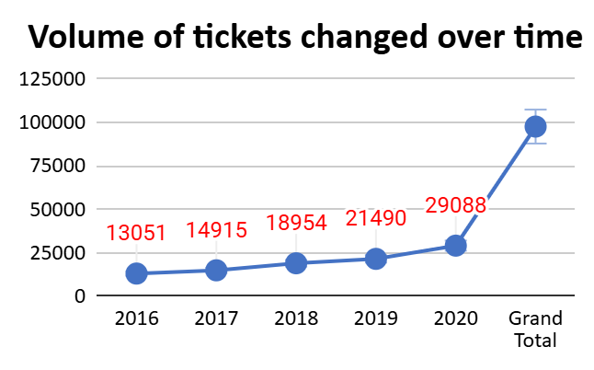

**12. Is there a correlation between the severity of issues and the resolution time?**

A correlation value close to 0 (like -0.04) suggests that there is almost no linear relationship between severity and resolution time.

Please find the below steps we followed to evaluate the correlation

Step 1: Assigned numeric values to the Severity Column

'0 - Unclassified' → 0

'1 - Minor' → 1

'2 - Normal' → 2

'3 - Mayor' → 3

'4 - Urgent' → 4

Applied below formula to get above results

=IF (G2="0 - Unclassified", 0, IF(G2="1 - Minor", 1, IF(G2="2 - Normal", 2, IF(G2="3 - Mayor", 3, 4))))

Step 2: Applied below formula on both severity and resolution time column

= CORREL (G2:G97499, I2:I97499)

**Conclusion**: The correlation between the severity of issues and the resolution time is approximately -0.04, indicating a very weak negative correlation

**13. How many categorical columns are there in the data? [Search about categorical and**

**continuous data, and try to answer this question]**

There are a total of 6 categorical columns in the dataset:

**Categorical Columns in the Tickets sheet:**

· Request Category

· Issue Type

· Severity

· Priority

**Categorical Columns in the IT Agents sheet:**

· Full Name

· Email Domain

**NOTE:(Please find the answers in (it agent/objectives ) and objective in google sheet)**

**Subjective Questions :-**

1. **If there is an investment, should it be used to hire more IT agents, improve training programs, or upgrade ticket management software?**

**Analysis**: Perform a cost-benefit analysis using ticket resolution and satisfaction metrics. We have 50 agent and they have Avg Resolution is 4.55 , Avg Satisfaction Rate 4.10 and ticket count is 1949.96

**Hire a Agent :-**

| Agent id | Count Of Id | Average Of Resolution Time | Average Of Satisfaction Rate |
| --- | --- | --- | --- |
| 3 | 2021 | 5.38 | 3.62 |
| 6 | 1949 | 5.32 | 3.59 |
| 7 | 1935 | 5.52 | 3.98 |
| 11 | 1956 | 4.78 | 3.64 |
| 14 | 1942 | 4.90 | 4.09 |
| 18 | 1892 | 4.73 | 3.99 |
| 19 | 1984 | 5.00 | 3.04 |
| 20 | 1920 | 4.41 | 4.15 |
| 22 | 1966 | 5.51 | 3.63 |
| 25 | 1906 | 5.20 | 3.60 |
| 26 | 1963 | 4.75 | 3.99 |
| 28 | 1946 | 5.41 | 3.61 |
| 30 | 1963 | 4.87 | 3.85 |

As we can see in the above table there are 13 agents that have high Resolution time and low Satisfaction Rate.

**Improve training programs:**

As we see only 5 agents have a low satisfaction rate.

| Agent Id | Count Of Id Ticket | Average Of Resolution Time | Average Of Satisfaction Rate |
| --- | --- | --- | --- |
| 9 | 1949 | 4.52 | 3.69 |
| 16 | 1926 | 4.32 | 3.67 |
| 40 | 1920 | 4.29 | 3.67 |
| 43 | 1897 | 3.85 | 3.91 |
| 44 | 1943 | 4.72 | 4.41 |

Here we can see High resolution time

| Agent Id | Count Of Id Ticket | Average Of Resolution Time | Average Of Satisfaction Rate |
| --- | --- | --- | --- |
| 1 | 1969 | 5.45 | 4.34 |
| 4 | 1988 | 5.24 | 4.19 |
| 13 | 1856 | 5.32 | 4.28 |
| 46 | 1950 | 5.32 | 4.32 |
| 49 | 1890 | 5.34 | 4.36 |
| 50 | 1949 | 5.45 | 4.20 |

**Upgrade Ticket Management Software :-**

| category | Avg of resolution time | avg og satisfaction rate |
| --- | --- | --- |
| Login Access | 0.3138081047 | 4.094508958 |
| System | 6.615609456 | 4.102302446 |
| Software | 5.238732754 | 4.106336229 |
| Hardware | 7.62539813 | 4.100996609 |

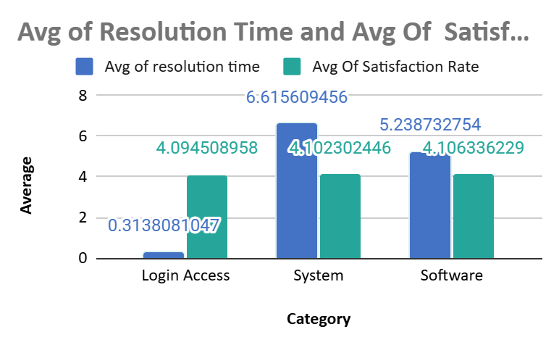

**Conclusion** – As per analysis of all above charts, I noticed that Resolution time is high in all conditions and Resolution means either we can give training to agents or upgrade ticket management software.

**2. Which agents need additional training based on their performance metrics?**

**Analysis**: To identify areas for improvement, we analyzed agents with the lowest satisfaction ratings or the longest resolution times. Among the 50 IT agents, the average resolution time stands at 4.55 days, while the average satisfaction rate is 4.10.

| Agent ID | Average Of Resolution Time | Average Of Satisfaction Rate |
| --- | --- | --- |
| 1 | 5.45 | 4.34 |
| 3 | 5.38 | 3.62 |
| 4 | 5.24 | 4.19 |
| 6 | 5.32 | 3.59 |
| 7 | 5.52 | 3.98 |
| 13 | 5.32 | 4.28 |
| 19 | 5.00 | 3.04 |
| 23 | 4.56 | 4.38 |
| 32 | 4.89 | 4.12 |
| 38 | 4.64 | 4.44 |
| 39 | 5.55 | 4.34 |
| 40 | 4.29 | 3.67 |
| 46 | 5.32 | 4.32 |
| 49 | 5.34 | 4.36 |
| 50 | 5.45 | 4.20 |

Our focus is on agents whose performance deviates from these benchmarks—specifically, those with resolution times exceeding the average or satisfaction rates below the average. Based on this analysis, a total of 15 agents have been identified as requiring additional support or training.

**3. Do certain categories of requests have longer resolution times?**

**Analysis**: To assess whether certain request categories experience longer resolution times, we analyzed the average resolution time across the four request categories: Hardware, Login Access, Software, and System.

| Request Category | AVERAGE of Resolution Time (Days) |
| --- | --- |
| Hardware | 7.625 |
| Login Access | 0.314 |
| Software | 5.239 |
| System | 6.616 |
| Grand Total | 4.55 |

From the analysis, it is evident that requests related to Hardware, Software, and System take significantly longer to resolve compared to Login Access, which has the shortest resolution time. This indicates a need to optimize processes and resources for these high-resolution-time categories to improve overall efficiency.

**4. How effective are the current software tools in managing IT tickets**?

**Analysis:** To evaluate the effectiveness of current software tools in managing IT tickets, we analyzed key performance metrics before and after the implementation of the new tools. The analysis included the year-wise count of requests categorized by Request Categories, Severity, and Priority.

The number of requests across all four categories (Hardware, Login Access, Software, and System) has steadily increased over the years.

| COUNTA of ID Ticket | Request Category |  |  |  |
| --- | --- | --- | --- | --- |
| year | Hardware | Login Access | Software | System |
| 2016 | 1272 | 3910 | 2617 | 5252 |
| 2017 | 1523 | 4526 | 2946 | 5920 |
| 2018 | 1844 | 5672 | 3735 | 7703 |
| 2019 | 2161 | 6426 | 4407 | 8496 |
| 2020 | 2933 | 8659 | 5865 | 11631 |

Requests categorized by severity levels (Unclassified, Minor, Normal, Major, and Urgent) also show a consistent rise over the years.

| COUNTA of ID Ticket | Priority |  |  |  |
| --- | --- | --- | --- | --- |
| year | 0 - Unassigned | 1 - Low | 2 - Mid | 3 - High |
| 2016 | 29.68% | 16.86% | 16.42% | 37.04% |
| 2017 | 30.20% | 17.28% | 16.16% | 36.35% |
| 2018 | 30.20% | 16.88% | 16.42% | 36.50% |
| 2019 | 30.34% | 17.16% | 16.15% | 36.36% |
| 2020 | 30.21% | 17.29% | 16.19% | 36.31% |

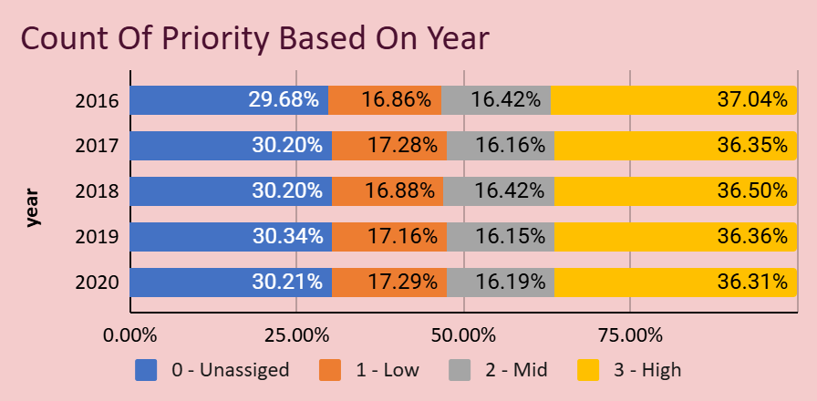

Tickets are categorized into four priority levels (Unassigned, Low, Mid, and High) and exhibit a clear upward trend in volume.

| COUNTA of ID Ticket | Severity |  |  |  |  |
| --- | --- | --- | --- | --- | --- |
| year | 0 - Unclassified | 1 - Minor | 2 - Normal | 3 - Mayor | 4 - Urgent |
| 2016 | 0.31% | 2.63% | 90.37% | 5.24% | 1.46% |
| 2017 | 0.23% | 2.29% | 91.14% | 4.89% | 1.45% |
| 2018 | 0.36% | 2.40% | 91.26% | 4.67% | 1.31% |
| 2019 | 0.46% | 2.32% | 90.64% | 4.98% | 1.60% |
| 2020 | 0.40% | 2.13% | 91.08% | 5.04% | 1.35% |

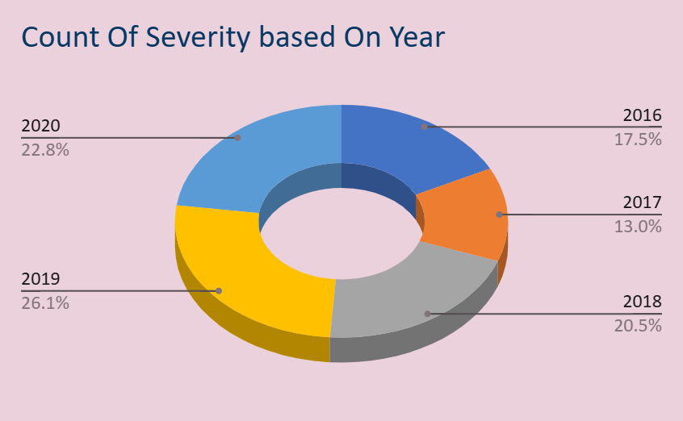

Most requests fall under Normal severity, with Major and Urgent showing significant growth in 2019 and 2020, indicating the importance of addressing critical issues effectively.

**Conclusion -** The analysis demonstrates that the current software tools have successfully managed the growing volume of IT tickets across all categories, severity levels, and priorities. However, the significant rise in High-priority and Urgent tickets suggests that while the tools are effective, there is a need to continuously refine them to handle critical and time-sensitive issues more efficiently.

**5. How has the performance of the IT support team changed over time (e.g., monthly or quarterly)?**

The IT support team's workload has increased steadily from 2016 to 2020, as reflected in the rising ticket volumes across quarters.

The sharp growth in ticket counts between 2019 and 2020 indicates an accelerated demand for IT support services

Ticket volumes show relative stability during Q2 and Q3.

| Year-Quarter | Ticket Count Range | Year-Quarter | AVERAGE of Satisfaction Rate | AVERAGE of Resolution Time (Days) |
| --- | --- | --- | --- | --- |
| 2016-Q1 | 3276 | 2016-Q1 | 3.95 | 4.55 |
| 2016-Q2 | 3265 | 2016-Q2 | 3.97 | 4.62 |
| 2016-Q3 | 3252 | 2016-Q3 | 3.98 | 4.54 |
| 2016-Q4 | 3258 | 2016-Q4 | 4.02 | 4.50 |
| 2017-Q1 | 3559 | 2017-Q1 | 4.07 | 4.56 |
| 2017-Q2 | 3834 | 2017-Q2 | 4.06 | 4.50 |
| 2017-Q3 | 3717 | 2017-Q3 | 4.07 | 4.53 |
| 2017-Q4 | 3805 | 2017-Q4 | 4.08 | 4.53 |
| 2018-Q1 | 4266 | 2018-Q1 | 4.13 | 4.55 |
| 2018-Q2 | 4936 | 2018-Q2 | 4.07 | 4.65 |
| 2018-Q3 | 4927 | 2018-Q3 | 4.09 | 4.50 |
| 2018-Q4 | 4825 | 2018-Q4 | 4.08 | 4.53 |
| 2019-Q1 | 5114 | 2019-Q1 | 4.13 | 4.55 |
| 2019-Q2 | 5152 | 2019-Q2 | 4.14 | 4.50 |
| 2019-Q3 | 5646 | 2019-Q3 | 4.13 | 4.50 |
| 2019-Q4 | 5578 | 2019-Q4 | 4.09 | 4.53 |
| 2020-Q1 | 7156 | 2020-Q1 | 4.14 | 4.62 |
| 2020-Q2 | 7012 | 2020-Q2 | 4.19 | 4.62 |
| 2020-Q3 | 7236 | 2020-Q3 | 4.18 | 4.54 |
| 2020-Q4 | 7684 | 2020-Q4 | 4.13 | 4.58 |
| Grand Total | 97498 | Grand Total | 4.10 | 4.55 |

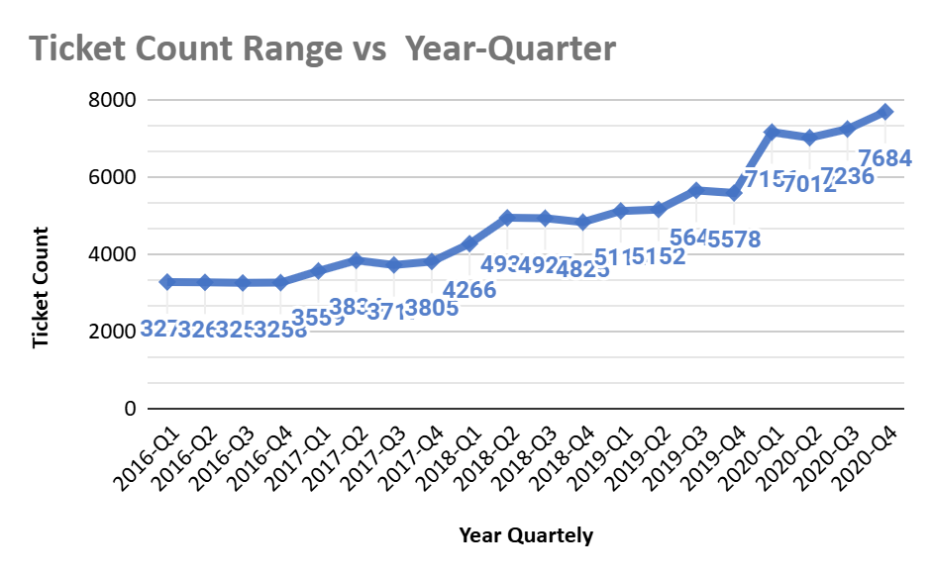

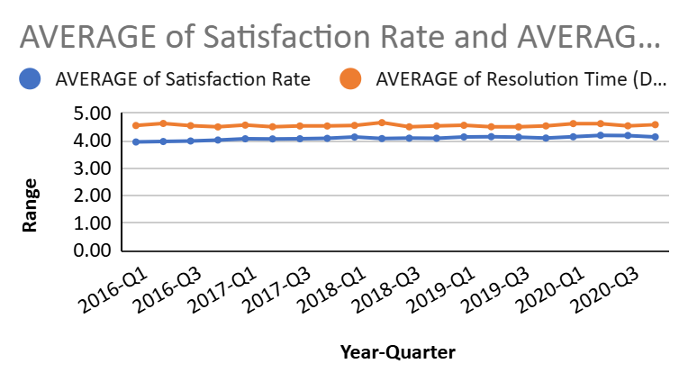

**Conclusion**: The IT support team's performance trends reflect increasing demand and clear seasonal patterns. Addressing the Q4 peaks through proactive planning and scaling operations will ensure smooth performance.

**6. If we invest more on tech (Hardware, software, etc), do you think it will improve the ticket resolution times and employee satisfaction?**

Hardware and System tickets have the longest average resolution times (7.63 and 6.62 days, respectively), significantly higher than Login Access (0.31 days).

Hardware, System, and Software tickets, satisfaction rates are relatively stable across all categories (4.09–4.11). This indicates user tolerance for delays in more complex issues but underscores the opportunity to improve satisfaction by reducing resolution time.

| Request Category | AVERAGE of Resolution Time (Days) | COUNTA of ID Ticket | AVERAGE of Satisfaction Rate |
| --- | --- | --- | --- |
| Hardware | 7.625 | 9733 | 4.10 |
| Login Access | 0.314 | 29193 | 4.09 |
| Software | 5.239 | 19570 | 4.11 |
| System | 6.616 | 39002 | 4.10 |
| Grand Total | 4.55 | 97498 | 4.10 |

Ticket volumes for all categories have shown consistent growth year over year, with a steep increase in 2020. This suggests a rising demand for IT support

| COUNTA of ID Ticket | Request Category |  |  |  |
| --- | --- | --- | --- | --- |
| year | Hardware | Login Access | Software | System |
| 2016 | 1272 | 3910 | 2617 | 5252 |
| 2017 | 1523 | 4526 | 2946 | 5920 |
| 2018 | 1844 | 5672 | 3735 | 7703 |
| 2019 | 2161 | 6426 | 4407 | 8496 |
| 2020 | 2933 | 8659 | 5865 | 11631 |

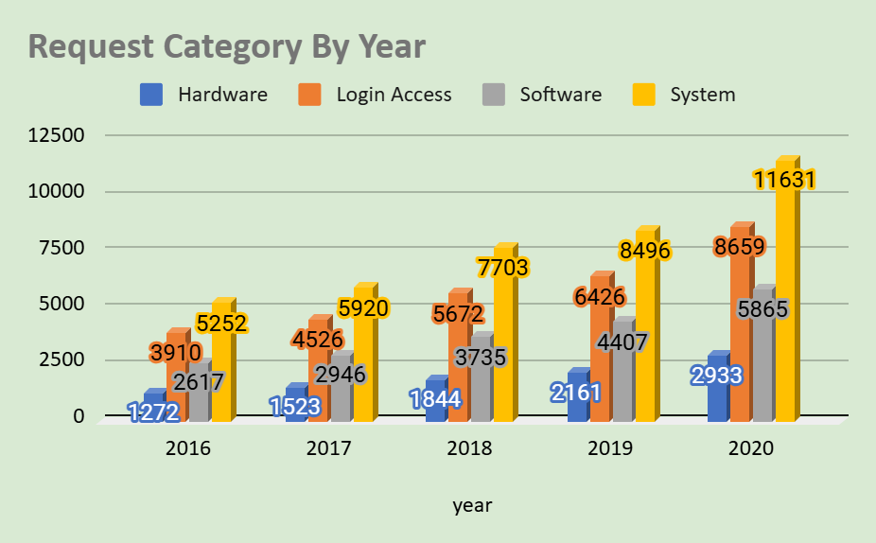

**Conclusion:** Investing in better technology, particularly for Hardware, Software, and System categories, is likely to significantly improve ticket resolution times and employee satisfaction. This investment will not only improve day-to-day operations but also future-proof the IT infrastructure against growing organizational needs.

**7. What are the key performance metrics for IT agents, and how can they be improved, do we need to fire any agents?**

Key Performance Metrics for IT Agent are:

Average Ticket Handling Time per Agent

* Average Satisfaction Rating per Agent
* Number of Tickets Resolved per Agent
* Performance Score based in Time and Rating

Based on the data provided, the following agents exhibit suboptimal performance in terms of higher resolution times and lower satisfaction ratings:

| Row Label | MAX Average of Resolution Time(AGENT ID) | MIN Average Of Satisfaction Rate |
| --- | --- | --- |
| 3.5 - 4 | 3.92 | 3.8 |
| 4 - 4.5 | 4.41 | 3.7 |
| 4.5 - 5 | 5.00 | 3.0 |
| 5 - 5.5 | 5.45 | 3.6 |
| 5.5 - 6 | 5.55 | 3.6 |

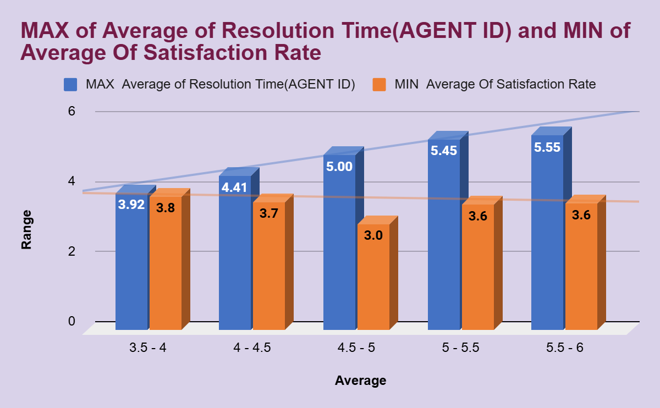

Recommendations for Improvement:

* Focused Training Programs
* Mentorship & Peer Learning
* Regular Feedback
* Tool Optimization

These steps will help improve the overall efficiency and satisfaction delivered by the IT support team, still if there is no change in performance we need to fire them.

**8. How do employee demographics (e.g., department, seniority) impact satisfaction and ticket outcomes**?

Agents in the 48–52 age group consistently achieve the highest satisfaction rates (4.39–4.49), suggesting their experience and expertise contribute positively to resolving tickets efficiently and meeting customer expectations.

Agents in this group maintain above-average satisfaction rates (4.14–4.38) and demonstrate steady performance across ticket resolution and customer feedback.

Satisfaction rates for younger agents are more variable, with some performing well (e.g., age 28: 4.23) and others facing challenges.

| Grouped Age | count of tickets id | Average Of Satisfaction Rate |
| --- | --- | --- |
| 28 - 29 | 2007 | 4.21 |
| 30 - 31 | 2021 | 4.03 |
| 32 - 33 | 1987 | 4.38 |
| 34 - 35 | 1984 | 3.70 |
| 36 - 37 | 1969 | 3.99 |
| 38 - 39 | 1968 | 4.31 |
| 40 - 41 | 2026 | 4.21 |
| 42 - 43 | 1966 | 3.85 |
| 44 - 45 | 2027 | 3.96 |
| 46 - 47 | 1988 | 4.33 |
| 48 - 49 | 1897 | 4.49 |
| 50 - 51 | 1958 | 3.82 |
| 52 - 53 | 2003 | 4.41 |

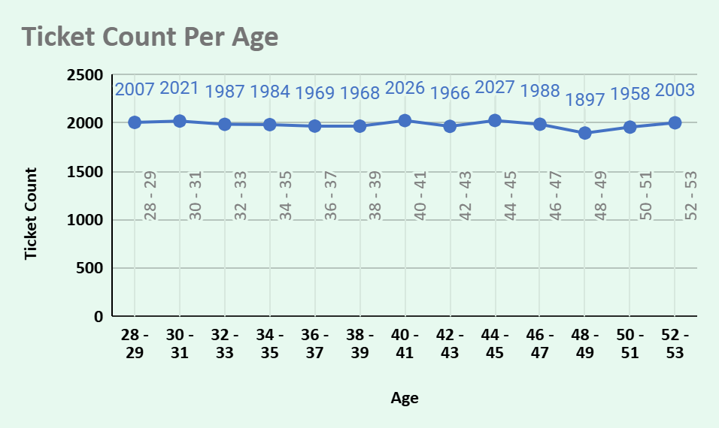

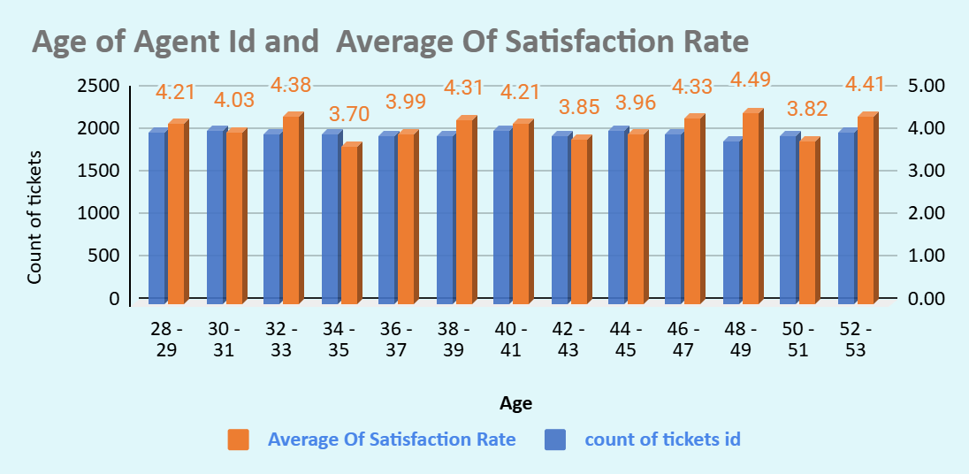

**Conclusion:** Employee demographics, particularly age and experience, significantly impact satisfaction and ticket outcomes. Senior agents (48–52) deliver consistently high satisfaction rates, while younger agents face challenges in managing complex tickets and maintaining satisfaction.

**9. Identify the trends for IT support operations based on ticket volumes and satisfaction, and mention the peak and stable times?**

Ticket volumes and satisfaction ratings remain relatively stable during the first two quarters, reflecting a manageable workload for IT teams. The highest ticket volumes occurred during this period, likely influenced by a surge in remote work and IT dependency.

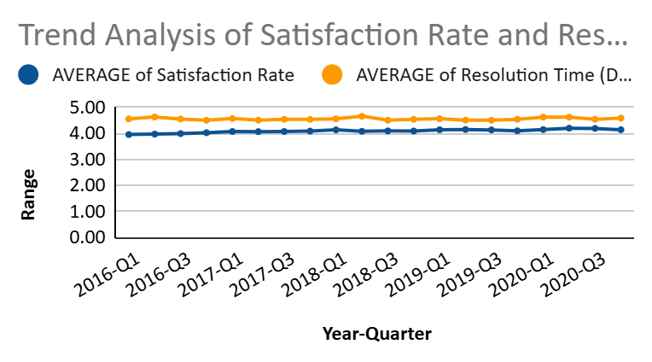

Ticket volumes have steadily increased year over year from 2016 to 2020. This growth indicates an expansion in the user base, increasing demand, or more efficient reporting mechanisms.

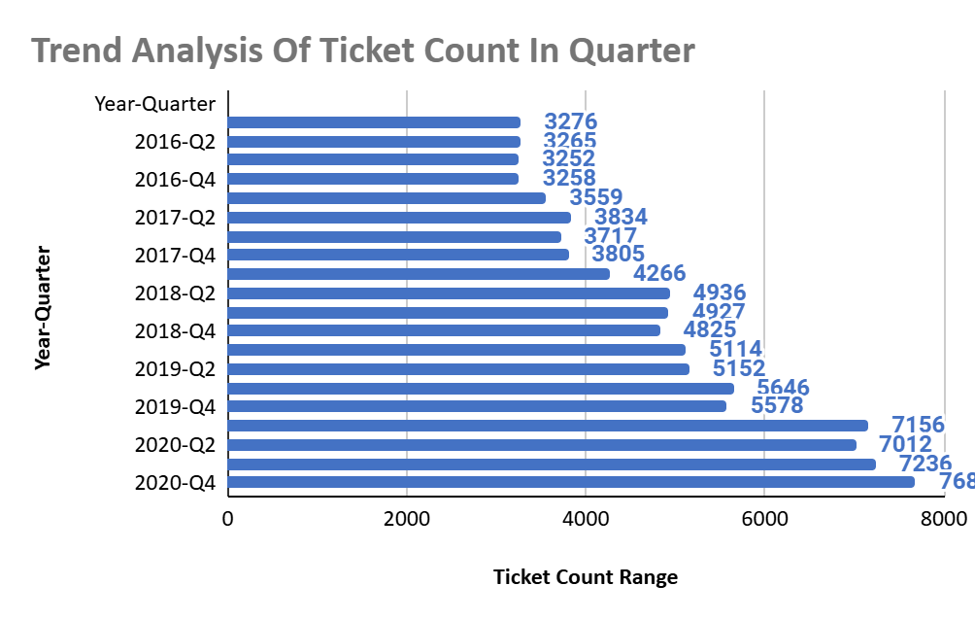

IT support operations have experienced a steady increase in ticket volumes, especially in complex categories like Hardware and System. However, workload peaks during Q2-Q4 2020 indicate a need for strategic resource planning during high-demand periods. Ensuring balanced workloads and training programs can help sustain satisfaction and efficiency during peak times.

**10. What metrics should be included in the final dashboard to provide a comprehensive view of call center performance and guide investment decisions?**

Following are the Metrics should be included for making dashboard of call center performance and guide investment decision:

* Ticket Management Metrics
* Customer Satisfaction Metrics
* Agent Performance Metrics
* Ticket Volume over Time
* Operational Efficiency Metrics
* Trends and Forecasts
* Technology and Resource Metrics

Recommendations:

* Visualization: Use dynamic charts and graphs to make trends and comparisons clear (e.g., bar charts for agent performance, line graphs for trends).
* Customizable Views: Allow users to filter data by time periods, categories, or teams.
* Real-Time Data: Incorporate real-time metrics for operational monitoring.

**Conclusion:**

By including these metrics, the dashboard will provide a complete picture of call center performance. It will allow stakeholders to identify bottlenecks, optimize processes, and make data-driven investment decisions to improve efficiency, customer satisfaction, and scalability.